TV Mounting Bracket

INLETS

BY: ASHAR AHMED JAVED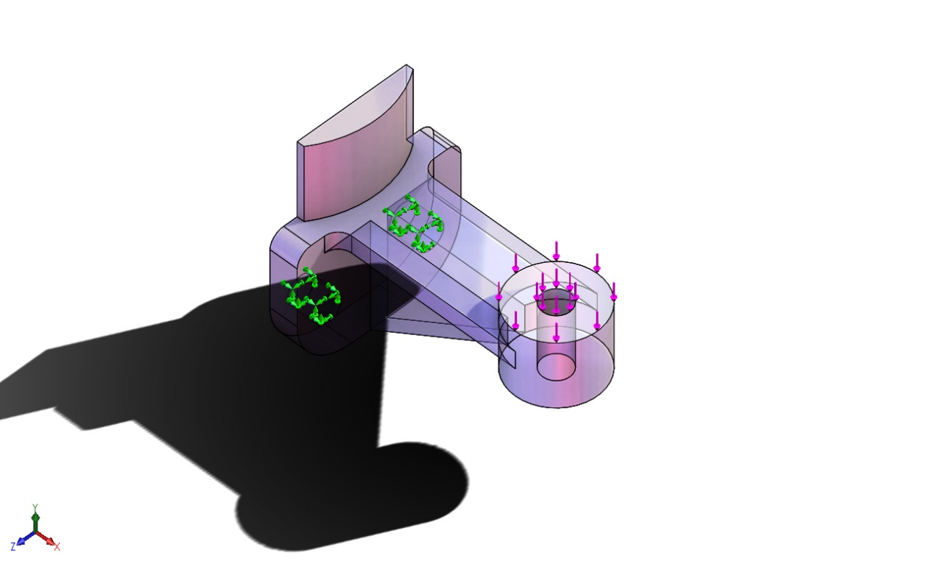

PURPOSE:

The purpose of this study was to evaluate the structural integrity of the engineered design, as well as to determine the elements of potential failure.

This study utilizes a provided design and FEA-Finite Element Analysis software was used to identify undesirable feature characteristics through computer simulation. This document presents chronologically the process of identification of engineered features.

**Material**: Acrylic (MPa Threshold 139.043 ≤)

|  |  |  |  |  |
| --- | --- | --- | --- | --- |
| |  | | --- | |  |   **Model name: TV Bracket**  **Current Configuration: FEA** | | | |
| **Solid Bodies** | | | |
| **Document Name and Reference** | **Treated As** | **Volumetric Properties** | **Document Path/Date Modified** |
| **Fillet2** | **Solid Body** | **Mass:0.185214 kg**  **Volume:0.000132295 m^3**  **Density:1,400 kg/m^3**  **Weight:1.81509 N** | **D:\New Life\Learning SOLIDWORKS\Vertanux1 Simulations\Lab 1\TV Bracket.SLDPRT**  **Mar 17 17:25:58 2025** |

|  |  |  |  |  |  |  |  |  |  |  |  |  |  |  |  |  |  |  |  |  |  |  |  |  |  |  |  |  |  |  |  |  |  |  |  |  |  |  |  |  |
| --- | --- | --- | --- | --- | --- | --- | --- | --- | --- | --- | --- | --- | --- | --- | --- | --- | --- | --- | --- | --- | --- | --- | --- | --- | --- | --- | --- | --- | --- | --- | --- | --- | --- | --- | --- | --- | --- | --- | --- | --- |
| **Loads and Fixtures**  | **Fixture name** | **Fixture Image** | **Fixture Details** | | --- | --- | --- | | **Fixed-1** |  | |  |  | | --- | --- | | Entities: | **2 face(s)** | | Type: | **Fixed Geometry** | | | **Resultant Forces**   |  |  |  |  |  | | --- | --- | --- | --- | --- | | **Components** | **X** | **Y** | **Z** | **Resultant** | | **Reaction force(N)** | **3.8147e-05** | **311.375** | **9.53674e-06** | **311.375** | | **Reaction Moment(N.m)** | **0** | **0** | **0** | **0** | | | |  | **Load name** | **Load Image** | **Load Details** | | --- | --- | --- | | **Force-1** |  | |  |  | | --- | --- | | Entities: | **1 face(s)** | | Type: | **Apply normal force** | | Value: | **70 lbf** | | |

ANALYSIS – A: F.O.S

TV MOUNTING BRACKET (ORIGINAL DESIGN)

Results: The TV Mounting Bracket seems to be over engineered.

During analysis we discovered the 70 LBF torque with a material yield strength of MPa 60 exceeds the given requirements by a factor of 10 times the desired outcome. This would lead us to believe the part as-is is over engineered.

SUMMARY: PASS – NOTE: OVER ENGINEERED BY A FACTOR OF 10x, OPTIMIZATION SHOULD BE EXAMINIED TO REDUCE MATERIAL COST.

| Name | Type | Min | Max |
| --- | --- | --- | --- |
| Factor of Safety | Automatic | 2.000e+00  Node: 1 | 2.000e+00  Node: 1 |
| **TV Bracket-Static-Factor of Safety-Factor of Safety1** | | | |

ANALYSIS – B: Von Mises

TV MOUNTING BRACKET STRESS ANALYSIS (REVISED/OPTIMIZED DESIGN)

Results: The TV Mounting Bracket appears to be designed well above expectation with regards to yield by being almost four times stronger than required. This may be over engineered.

SUMMARY: PASS

| Name | Type | Min | Max |
| --- | --- | --- | --- |
| Stress1 | VON: von Mises Stress | 5.840e-03N/mm^2 (MPa)  Node: 2563 | 1.508e+01N/mm^2 (MPa)  Node: 179 |
| **TV Bracket-Static-Stress-Stress1** | | | |

ANALYSIS – C

TV MOUNTING BRACKET DISPLACEMENT ANALYSIS

Results: The TV Mounting Bracket bends in the downward direction approximately by 4 mm, which may indicate a stiffer material should be considered.

SUMMARY: PASS

| Name | Type | Min | Max |
| --- | --- | --- | --- |
| Displacement1 | URES: Resultant Displacement | 0.000e+00mm  Node: 1 | 3.960e-01mm  Node: 597 |
| **TV Bracket-Static-Displacement-Displacement1** | | | |